**Highlights**

* Evacuation mode, road environment, and traffic can influence pre-hospital time (PHT)
* The above factors can also affect injury severity score (ISS) via PHT in road crashes
* With hospital crash data, this study examines the above relations via path analysis
* Ambulance evacuation and nighttime significantly increase ISS directly and via PHT
* Overall effects on ISS surpass direct effects, stimulating debate on countermeasures

**How Mode of Evacuation, Roadway Environment, and Traffic Conditions Relate to Injury Severity Score? Untangling the Role of Pre-hospital Time in Road Crashes**

**Zia-Ur-Rehman**

Graduate Student – MS in Transportation Engineering

National Institute of Transportation

National University of Sciences and Technology, Risalpur, Pakistan

Email: [malikzia2008@gmail.com](mailto:malikzia2008@gmail.com)

**Numan Ahmad, Ph.D. (Corresponding Author)**

Assistant Professor in Transportation Engineering and HoD Research

National Institute of Transportation

National University of Sciences and Technology, Risalpur, Pakistan

Email: [numan.ahmad@nit.nust.edu.pk](mailto:numan.ahmad@nit.nust.edu.pk); [hodresearch@nit.nust.edu.pk](mailto:hodresearch@nit.nust.edu.pk)

**Afzal Ahmed, Ph.D.**

Teaching Fellow in Transport Planning and Engineering

Institute for Transport Studies, University of Leeds, United Kingdom

Co-Chair and Associate Professor, Department of Urban and Infrastructure Engineering,

NED University of Engineering and Technology,

University Road, Karachi-75270, Pakistan

Email: [A.Ahmed@leeds.ac.uk](mailto:A.Ahmed@leeds.ac.uk); [afzalahmed@neduet.edu.pk](mailto:afzalahmed@neduet.edu.pk)

**Syed Kamran Hussain Shah, Ph.D.**

Assistant Professor in Geotechnical Engineering

National Institute of Transportation

National University of Sciences and Technology, Risalpur, Pakistan

Email: [kamran.hussain@nit.nust.edu.pk](mailto:kamran.hussain@nit.nust.edu.pk)

**Dr. Izza Anwer, Ph.D.**

Assistant Professor

Department of Transportation Engineering and Management

University of Engineering and Technology, Lahore, Pakistan

Email: [engr_izza@hotmail.com](mailto:engr_izza@hotmail.com)

Abstract

This study explores the effects of some of the key factors, including emergency response measures, roadway and environment, traffic-related attributes, and crash-specific factors, on the Injury Severity Score (ISS) of Road Traffic Crashes’ (RTCs) victims, both directly and through pre-hospital time (PHT) using rigorous path analysis. Data for 298,654 crashes, compiled by the Road Traffic Injury Research and Prevention Center (RTIRPC) in Karachi (Pakistan), were used for analyses. Owing to the corner-solution distribution of the response variables (PHT and ISS), two Tobit regression models are estimated after accounting for missing values through synthetic data generation. Marginal effects from these models are used in the path analysis. The findings suggest that ISS increases by 0.01 units with a unit increase in PHT, highlighting the critical need for rapid evacuation of crash victims to medical facilities. The mode of evacuation emerged as a crucial factor, with ambulances resulting in increased PHT and ISS compared to private or public transport, underscoring the improvement needed in the dedicated ambulance-based emergency response. PHT and ISS were found to be higher in nighttime crashes, necessitating better emergency medical services (EMS) response during the night. Intersection crashes were associated with lower PHT and ISS; whereas, crashes on undivided roads and those involving multiple or large vehicles increased PHT and ISS. The path analysis revealed that the overall effects of some of the key variables on ISS were higher than their direct effects – something that could not be explored without the path analysis. These insights can help policymakers develop strategies to improve emergency response and road safety, ultimately reducing the number of RTC-related injuries and fatalities.

**Keywords**: Pre-hospital time, Injury severity score, Road traffic crashes, Synthetic data, Tobit regression, Path analysis, Emergency medical services

# **Introduction**

With 20 to 50 million road traffic injuries (RTIs) and 1.19 million road traffic fatalities (RTFs) annually worldwide, road traffic crashes (RTCs) have become a serious public health concern [1]. The situation is severe, especially in low- and middle-income countries, defined as those with a gross national income (GNI) per capita of $13,845 or less in 2022 [2]. The fatality rate from RTCs in low- and middle-income countries is approximately twice that of their high-income counterparts [2]. The outcome for victims of RTCs largely depends on receiving timely and efficient medical care. One critical aspect of medical treatment is the time between the occurrence of a crash and the provision of proper medical care, either on the spot or at hospitals/emergency units. The total pre-hospital time (PHT), which encompasses the time between the occurrence of an RTC and the crash victim's arrival at the hospital, can be divided into multiple phases: response time, scene time, and transport time. The time between the emergency medical services (EMS) notification and their arrival at the RTC scene is usually termed the “response time”. “Scene time” refers to the duration between EMS arrival at the crash scene and their departure for the hospital. “Transport time” is the time it takes to travel from the crash scene to the hospital if additional medical treatment is needed [3]. Contrary to the developed countries, in low- and middle-income countries, crash victims are frequently transported to hospitals by family members, taxi drivers, truck drivers, police officers, or other road users, many of whom lack formal training. The dedicated (but limited) ambulance service is generally accessible only in urban areas. Many neurological injuries appear to be the consequence of inadequate immobilization or improper extraction procedures during the carriage of crash victims, which is frequently performed by individuals who lack adequate training. Past research suggests that the severe consequences of RTIs are predominantly attributable to inadequate public health infrastructure and limited access to (or poor) healthcare services [4]. The time to provide medical care to the victims of RTCs becomes more important in cases where the first medical aid is either unavailable or the victims need to be shifted to hospitals for extensive or additional treatment due to severe injuries. These situations are more critical as the PHT may significantly determine the final injuries and survival of the victims in RTCs who are to be shifted to the hospital(s) for extensive treatment.

Understanding the effects of the leading factors (i.e., roadway and environmental factors, traffic-related attributes, and response as well as evacuation-related factors) on injury outcome(s) of RTCs is significant, and several past studies have analyzed these relationships via traditional modeling approaches, usually capturing only the direct associations. However, we consider that in addition to the direct effects, the abovementioned factors can have a significant association with the injury outcomes through some of the mediating variables (i.e., PHT in the present case), which, if not captured, the overall relationships may be overlooked. To the best of the authors' knowledge, none of the studies investigated how the above-mentioned factors relate to ISS (being a fine injury measure), both directly and via PHT. Furthermore, recognizing the critical role of PHT in determining the injury outcome(s) of RTCs, it is vital to understand how various roadway and environmental factors, traffic-related attributes, response as well as evacuation-related factors relate to the PHT. For instance, the PHT for the victims in an RTC occurring on a roadway segment may significantly differ from that at intersections, as the chance of being timely noticed and assisted can be higher in the latter case. Similarly, different roadway types, weather, light conditions, crash locations, time of the crash, etc., may have diverse effects on the PHT. While studies mostly investigated how various roadway and environmental factors relate to response time, the factors affecting the “pre-hospital” time (which mostly relate to more critical injuries to be treated at hospitals) are lightly researched. In particular, the association of some of the important factors e.g., roadway types (divided versus undivided, and number of lanes, etc.), visibility-related factors (weather and light conditions), crash locations (segments versus intersections), and time of the crash considering traffic flow (peak versus off-peak hours), etc. with the PHT needs an in-depth investigation. As discussed earlier, the above-mentioned factors may also significantly relate to the injury severity directly. To understand the overall effects of the aforementioned factors on injury severity, it is important to unveil the effects of these factors on injury severity (especially using hospital-based fine injury data and measures like Injury Severity Score “ISS”), both directly and indirectly (via PHT) which are not well investigated to date.

This research aims to bridge the aforementioned gaps by investigating how the above-mentioned factors relate to ISS both directly and indirectly (via PHT) using rigorous path analysis while analyzing nine years (2007 to 2015) of hospital-based RTCs data collected by the Road Traffic Injuries Research and Prevention Center (RTIRPC) for Karachi, Pakistan. In particular, complex pathways leading from diverse roadways and environments, and crash- as well as response-related factors to ISS are aimed to be explored in this study, which can provide a more comprehensive and in-depth picture of the system.

# **Literature review**

Several injury classification systems are employed to categorize the injuries experienced by roadway users involved in RTCs [5, 6]. The often-employed injury severity scales in transportation engineering include the KABCO Scale, Abbreviated Injury Scale (AIS), and Injury Severity Score etc. The KABCO injury scale serves as the basis for injury data recorded in police crash reports. It involves a five-point scale (Fatal (K), Serious (A), Moderate (B), Minor (C), and None (O)) to assess the severity of an RTC. In general, the KABCO scale offers a simple and easy-to-understand system for categorizing injuries. However, it also has obvious limitations [7, 8, 9, 10, 11, 12]. In contrast to the KABCO scale, the AIS is a global severity scoring system that is anatomically based, consensus-derived, and considers the relative significance of each injury in classifying it by body region on a six-point ordinal scale: 1 = Minor injury, 2 = Moderate injury, 3 = Serious injury, 4 = Severe injury, 5 = Critical injury, and 6 = Un-survivable (fatal) injury. The AIS assigns a numerical value to each injury based on its level of severity. Based on the anatomical structure, the human body can be categorized into nine body parts as shown in Figure 1 [13, 14]. Although the AIS describes anatomical injuries, it lacks internal consistency. Nevertheless, the anatomically based AIS has served as the foundation for various anatomical assessments of injury severity, such as the ISS [9, 15, 16]. The ISS is a well-established medical scoring system and is considered the leading and most reliable system for assessing injuries [14, 16]. The ISS is highly pertinent to evaluating the severity of injuries in RTCs as it enables the assessment of multiple injuries in several body regions. Specifically, the ISS is determined by considering the AIS scores of the three most serious injuries in three distinct anatomical locations.

Past research shows that ISS has a high level of proficiency in forecasting mortality, morbidity, and the duration of hospitalization [9, 17, 18, 19]. Previous research has found a wide range of factors that are associated with RTCs of different levels of injury severity. The investigation largely considered the impact of driver demographics and behavior, crash characteristics, roadway features, and environmental variables. Research also indicated that there are three main elements that have an impact on RTCs: traffic characteristics, road network and infrastructure, and demographic and environmental features [20]. It is also highlighted that several factors significantly influence road traffic casualties, including gender, vehicle condition, safety status, overloading, street lighting, weekends, type of vehicle, driver experience, morning rush hours, and severe weather conditions [21].

The idea of the "Golden Hour" emphasizes the significance of the period before arrival at the hospital in providing care for trauma patients. Most trauma experts believe that the initial 60 minutes following a crash, commonly known as the "golden hour," are crucial for maximizing the chances of preserving lives. Following this period, there is a substantial increase in the likelihood of fatality or the severity of injuries [22]. Unfortunately, the quality of pre-hospital care in many low- and middle-income countries is inadequate, resulting in a significant number of deaths during the pre-hospital stage [22]. Due to the absence of established EMS systems in most of these countries, most crash victims are rescued by bystanders at the crash scene. Moreover, many of these bystanders rely on commercial vehicles to transport the crash victims to a healthcare facility [23]. Consequently, a considerable number of neurological injuries appear to occur due to the procedure of extrication or shifting the crash victims without appropriate immobilization, which is frequently carried out by inexperienced persons [22].

**PASTE FIGURE 1 HERE**

Studies show that several socio-demographic characteristics are strongly linked to various aspects of response time, such as geographical regions, types of crash, age, gender, and nationality. Gaining a comprehensive understanding of these elements is crucial for maximizing efficiency during the period spent before reaching the hospital [24]. Furthermore, places exhibit pre-hospital delays that are correlated with criteria such as older age, living in rural areas, and the level of consciousness of crash victims [25]. Environmental and infrastructural variables, such as the day of the week, whether the site is urban or rural, the exact details of the crash, and the time it takes for emergency response, have a considerable impact on the time it takes to clear the scene and the total duration during peak traffic hours. The delays in transferring crash victims to hospitals are sometimes caused by the unavailability of specialized transportation, communication difficulties, and a lack of awareness regarding nearby medical services [2, 26]. The EMS plays a vital role in minimizing the duration of care provided before a patient reaches the hospital.

The association between prehospital time and injury severity has primarily been studied in developed countries. However, it is still uncertain whether these findings can be applied to developing countries, particularly in low-resource settings, due to the existing status of pre-hospital and in-hospital care [27]. Moreover, the available literature clearly shows that both the direct effects of PHT and factors (i.e., environmental, highway, and crash-related elements) affecting it can have a significant influence on injury outcomes. Hence, in order to comprehend the comprehensive impact of the aforementioned elements on ISS, it is crucial to uncover their direct and indirect effects on ISS, particularly via PHT. Although the literature has documented the direct impact of the aforementioned factors (including PHT) on ISS, gaining an understanding of the indirect effects of these factors on ISS (via PHT) can offer valuable insights for developing or improving a comprehensive strategy to enhance road safety and decrease injury severity for victims of RTCs. For a summary of the relevant past literature, please refer to Table 1.

**PASTE TABLE 1 HERE**

# **Methodology**

## *3.1. Data Source*

This study analyzes the RTCs data acquired from the Road Traffic Injuries Research and Prevention Center (RTIRPC) for a period of nine years (2007 to 2015), focused on Karachi, Pakistan. The dataset contains details about 298,654 crashes and includes extensive information such as demographic, socioeconomic, roadway and environmental, and crash-related aspects. During the data cleaning process, we noticed that 160,365 entries (which accounted for approximately 54% of the total) had missing or improper values for one or more variables. For instance, there were ~7% (N=20,465) cases in which no AIS score was assigned to any of the nine body parts despite being taken to hospitals for treatment. This resulted in 138,289 entries (approximately 46%) having complete and accurate information for all the variables of interest. To address this problem, synthetic data generation techniques were used to account for the missing or incorrect values by generating 160,365 entries, using the distribution of the key variables of interest (along with their correlation with each other), from the cleaned data (N = 138,289). Subsequently, the final dataset with a sample size of 298,654 observations was used for analyses.

## *Synthetic Data Generation*

The employment of synthetic data in this context is relevant, as it guarantees the optimal utilization of vital information that could otherwise be lost owing to improper or missing inputs arising from data entry errors. The "synthpop" program in R software was utilized to generate a synthetic dataset for the key variables based on the complete observed data. The "synthpop" technique involves the selection of an initial variable (by the user) to be synthesized, followed by the generation of values randomly using a method that samples with replacement from the observed data with complete information [28, 29]. Then, a parametric or non-parametric approach can be selected in the synthpop technique to predict the values of subsequent variables, utilizing the previously synthesized variables as predictors [30, 31]. This study used a non-parametric classification and regression tree (CART) approach for synthetic data generation. The selection of the CART method, whether it is regression or classification, was determined by the nature of the variable, such as whether it is continuous, binary, or categorical. This method generated a synthetic data clone, which was similar to the original data in terms of the distribution of variables and correlation among them, therefore maintaining the accuracy and usefulness of the dataset [28, 31]. For an in-depth understanding of the methodology, please refer to the studies in parentheses [28, 30, 29, 32, 33, 34].

## *Injury Severity Score*

To calculate the ISS for a particular crash victim, the nine body parts (head, face, neck, thorax, abdomen, spine, upper extremity, lower extremity, and external) are classified into six ISS body regions as shown in Figure-1. The injury is evaluated at each specific anatomical location, and a severity score based on the AIS is assigned to each individual injury. Then the highest severity code (AIS) for each of the three most severely injured body regions is squared and then summed to obtain the ISS score for a crash victim, which can be shown below:

(1)

Where X, Y, and Z represent the AIS scores of the three body regions with the most serious injuries according to the ISS scale. The ISS scores span a range of 1 to 75.

## *Conceptual Framework*

This research aims to examine the relationships of various factors, including roadway and environmental factors, and crash- and response-related aspects with the ISS of the victims in RTCs both directly and through PHT. The motivation for this research is based on our hypotheses that various factors, including the characteristics of the road (such as the presence of a median, number of lanes in each direction, etc.), the location of the crash (at an intersection or on a straight portion), the time of day (day or night), and the volume of traffic (during peak or off-peak hours), can have statistically significant effects on the PHT where the latter may significantly relate to the ISS. For example, during peak hours, congested, undivided roadway portions may have prolonged PHT for RTCs due to the complex road network and dense traffic, which may hinder the prompt arrival of emergency personnel. In contrast, RTCs occurring on uncongested divided roadway segments during non-peak hours may encounter faster response times, resulting in shorter pre-hospital durations. Furthermore, we consider that there can be a potential direct association of roadway and environmental conditions, and crash- and response-related factors with ISS. In order to systematically approach the research objectives, this study uses a two-stage path analysis (as depicted in Figure 2) to understand the overall effects of the key variables on the ISS while accounting for indirect pathways from these factors to the ISS via PHT.

**PASTE FIGURE 2 HERE**

## *Modelling Framework*

This study used the Tobit model due to the continuous nature and distribution of the response variables (PHT for Model 1 and ISS for Model 2) in our data. The Tobit model is appropriate for addressing the corner-solution problem, which occurs when the dependent variable shows clustering or a spike at its lowest and/or highest extreme value [35, 7]. This characteristic was observed in both ISS and PHT in this study where the two variables exhibit spikes at the lower end. A brief description of the Tobit model can be found below:-

### *Tobit Regression*

In the statistical literature, truncation and censoring are regarded as distinct phenomena; however, they both pertain to data observability concerns [36, 37, 38]. Censoring refers to a situation when a significant proportion of observations exceed the censoring threshold or events are not recorded for a considerable number of observations. Alternatively, truncation happens when a substantial number of observations surpasses the maximum observable range. Even without any censoring or truncation, the dependent variable can exhibit a cluster at the lowest extreme value (spike at 0 or 1), which is referred to as a corner-solution problem. In our case, we observed that both the distribution of ISS and the PHT exhibit a left spike, indicating corner-solution problems. It is important to highlight that there is no issue with data observability in our case. To fully incorporate and take into account all observations, research indicates that Tobit regression can be employed for all three phenomena [35, 36, 37, 38]. Thus, in this study, Tobit regression is used to estimate the ISS and PHT because of the corner-solution setup seen in the ISS and PHT:-

(2)

(3)

(4)

In equation (2), the latent variable (stochastic index) is denoted as 𝑌𝑖∗, the observed dependent variable is 𝑌𝑖, 𝜷𝟏 represents a set of estimable parameters associated with independent variables (𝐗𝒊), 𝑁 represents the number of observations, and 𝜀1 represents residuals that are assumed to follow a normal distribution with 𝐍(𝟎, 𝛔𝟏²). The log-likelihood function for Tobit regression can be derived as follows:-

(5)

In equation (5), 𝜏 represents the threshold in the data where a corner-solution (left-spikes) is observed, ∅ denotes the standard cumulative normal distribution function, and ∅ represents the standard normal density function. By setting 𝜏 = 0 and expressing 𝜇 as a function of observed variables and their estimated parameters (𝛽1X𝑖), the log-likelihood function for the Tobit model can be obtained:-

(6)

By further expanding equation (6), the log-likelihood functions can be expressed as:

(7)

The equation (7) comprises two components: 1) the standard regression for uncensored observations and 2) the probability of censoring for specific observations. Marginal effects (MEs) can be calculated to see the impact of a unit increase in a specific continuous variable (or a transition from 0 to 1 in an indicator) on the response variable while holding all other variables in the model at their average values. Three distinct forms of MEs can be determined in Tobit regression, based on different predicted values of the dependent variable [39]. It should be noted that, depending on the extent, one or more of these MEs can be utilized. With that being stated, we calculate and furnish all three MEs for this research. However, we eventually utilize and interpret ME-1. It should be noted that ME-1 is calculated using both uncensored and censored observations. In our scenario, the ISS and PHT suggest a situation where the lowest limits are reached, known as a corner solution with left spikes [35, 39]. However, there is no actual censorship, as previously mentioned. Therefore, we employ ME-1, taking into account both censored and uncensored data, as shown below:-

(8)

To calculate the chance of an observation being uncensored, ME-2 can be determined using the following method:-

(9)

The equation (10) provided below can be utilized for MEs (ME-3) that rely solely on unfiltered observations of response variables:-

(10)

Where, (11)

It is important to mention that the ME-3 is more applicable in situations of "true censoring," which is not the case in this study.

In summary, we employed the ME-1 method, which incorporates both censored and uncensored observations, from the Tobit model in our final path analysis. This allowed us to assess the indirect and total effects of PHT and other important factors on ISS [35, 40].

## *Path Analysis*

Within the path analysis framework, the MEs obtained from the individual models are utilized to ascertain the direct, indirect, and overall effects of relevant factors on the ultimate response variable (ISS), as depicted in Figure 1 [41, 42]. The impact of a specific independent variable on the ISS is determined by multiplying the estimated effects (MEs) obtained from the PHT model (Model 1) with the ME of PHT obtained from the ISS model (Model 2). It should be noted that the "ISS model" quantifies the direct impact of the leading independent factors, and PHT on ISS sustained by a crash victim. When combined with the indirect effect, these factors provide the overall impact of a specific explanatory variable on ISS. The equations for calculating the indirect and total impacts of certain explanatory variables are provided below [12, 43, 44]:-

Indirect MEs = (MEs from PHT model) *(MEs of PHT from ISS model) (12)

Total MEs = Direct MEs + Indirect MEs (13)

While consistent estimates can be obtained via standard path analysis (i.e., independent estimation of models), studies suggest that achieving more efficient results if potential correlation between the unobserved factors exists and is taken into account via joint estimation[35, 45]. To account for potential correlation between the unobserved factors which can be associated with both PHT and ISS, we used the limited information maximum likelihood procedure for the estimation of the two models jointly via Conditional Mixed Process (CMPT), where the latter is a user-written STATA routine [46]. The joint estimation considers the two error terms (𝜀1 𝑎𝑛𝑑 𝜀2), associated with PHT and ISS, to have multivariate normal distribution [46].

# **Results**

## *Actual Versus Synthetic Data*

The cleaned RTIRPC data, which consisted of 138,289 observations, were employed to produce a synthetic dataset with 160,365 observations, as previously mentioned. Subsequently, these datasets were merged to produce a combined sample size that was equivalent to the original RTIRPC data (N=298,654). The distribution of key variables in both the actual and synthetic datasets is compared in Figure 3. The synthetic data's distribution of all variables appears to be reasonable when compared with the actual (observed) data. Comparisons are presented for only a subset of the key variables for brevity. The descriptive statistics for these variables are compared across the actual and synthetic data samples in Table 2. The means and standard deviations of the key variables in the synthetic data are in close agreement with those of the actual data.

**PASTE FIGURE 3 HERE**

**PASTE TABLE 2 HERE**

## *Descriptive Statistics*

Figure 4 illustrates the distribution of two dependent variables, namely PHT and ISS. Both of these variables are characterized by a corner-solution set-up, which enables them to be modeled using Tobit regression. For further information, please refer to the methodology section.

**PASTE FIGURE 4 HERE**

The summary statistics of the key variables are displayed in Table 3. The mean ISS for individuals involved in crashes is 6.20, with a standard deviation of 11.80. The mean PHT is 104.30 minutes, with a significant standard deviation of 205.66 minutes, while the longest reported PHT is 1439 minutes. While the maximum value of PHT (1439 minutes ~ 24 hours) may seem to be an outlier, we included crashes with such large values to highlight the slow response and its consequences. Out of all the crashes, a significant percentage of 35.68% took place on roads that had four lanes in each direction. Moreover, 75% of crashes occurred on straight road segments, while 37% occurred at night. Figure 5 shows the distribution of variables, including the type of vehicles, type of crash victims, and mode of evacuation associated with RTCs. Referring to the distribution of crashes based on the vehicle types involved, motorcycles accounted for the largest proportion of crashes (69.41%), followed by other vehicles such as taxis (7.58%), buses (5.27%), passenger vans (2.42%), bicycles (1.32%), trucks (1.76%), private automobiles (0.97%), and rickshaws (three-wheelers) (0.35%). The most susceptible individuals involved in RTCs were riders and passengers of two-wheelers, as well as pedestrians, accounting for 48.12%, 13.78%, and 23.08% of the total crash victims, respectively. In terms of the mode of evacuation, 61.00% of crash victims were taken to medical facilities utilizing private transport, while 34.33% made use of ambulance services. For the distribution of other key variables, please refer to Table 3.

**PASTE FIGURE 5 HERE**

**PASTE TABLE 3 HERE**

## *Modeling Results*

The final models (Model 1 and Model 2 for PHT and ISS, respectively) were systematically derived for each outcome type, incorporating the most significant variables (based on the research objectives), statistical significance, intuition, theoretical justifications, and specification parsimony. To this end, the likelihood ratio test and improvement in the AIC and BIC statistics were considered. A 95% confidence criterion was employed to determine the statistical significance of the variables in either model. The subsequent subsections provide details about key findings that were obtained from both models. While the final modeling results (below) are based on the models which were estimated in an independent fashion, we want to mention that we tried to estimate the two models in a joint fashion (as discussed in sub-section 3.6) to account for potential correlation between the unobserved factors associated with PHT and ISS. However, there was no significant evidence found that a significant correlation exists between the unobserved factors associated with the two dependent variables (i.e., PHT and ISS). As discussed earlier, the results obtained from the independent models are still consistent and used in recent research studies based on the independently estimated models.

### *Model 1: Factors Affecting Pre-Hospital Time*

The results of the final PHT Model suggest a significant reduction in PHT for RTCs which occur at intersections (compared to mid-block locations), on roadway segments with fewer than four lanes per direction, involve VRUs (especially pedestrians and cyclists), and if the post-crash evacuation is carried out by modes other than a dedicated ambulance service. On the other hand, PHT is significantly higher for RTCs occurring on undivided roadways, in seasons other than summer, during nighttime, and in RTCs with multiple or heavy vehicles involved. As stated in the footnote of Table 4, there was no statistical evidence of multicollinearity among the variables included in the final model. For detailed results and relevant discussion of the model results, please refer to Table 4 and the discussion section, respectively.

**PASTE TABLE 4 HERE**

### *Model 2: Factors Affecting Injury Severity Score*

In the final ISS model, we found 13 explanatory variables, including PHT, to have statistically significant (as per 95% confidence level criteria) association with ISS (Table 5). The final model underscores a significant association of the PHT with the ISS, indicating that as PHT increases, the ISS also tends to increase significantly. The higher degree polynomial (i.e., squared term) of PHT shows a significant correlation with ISS, indicating sufficient evidence of non-linearity in the association of PHT with ISS. Furthermore, RTCs, which occur on undivided roadway segments at nighttime, on Fridays, and involve VRUs, lead to significantly higher ISS for the crash victims. Similarly, the involvement of multiple or heavy vehicles in RTCs tends to result in higher ISS. On the other hand, ISS significantly reduces for the victims in RTCs which occur at intersections (as opposed to mid-block locations), on roadways with fewer than 4 lanes in each direction, during time other than morning peak hours, during seasons other than summer, and if post-crash evacuation is carried out via modes other than ambulance. Furthermore, a significant positive correlation between the number of body parts injured in a crash and the ISS was found. For inclusive results and discussion, please refer to Table 5 and the discussion section, respectively. Furthermore, there is a significant positive correlation between the number of body parts injured in a crash and the ISS, with each additional injured body part resulting in a higher ISS.

**PASTE TABLE 5 HERE**

### *Path Analysis*

Table 6 presents the results of the path analysis, which uncovers the direct and indirect relationships of the key factors (i.e., related to roadways and environment, response, traffic, and crash) with the ISS for the victims of RTCs. The direct effects of key explanatory variables on the ISS (ME-1) are obtained from Table 5, which is based on Model 2. Whereas, in order to determine the indirect effects of key explanatory variables on ISS, we compute them by multiplying the ME (ME-1) of each individual variable from Model-1 with the ME (ME-1) of PHT on ISS obtained from Model-2. The outcomes of these computations, which emphasize the indirect effects of the key explanatory variables on ISS, are compiled in Table 6, which presents the direct, indirect, and total impacts of each explanatory variable.

**PASTE TABLE 6 HERE**

# **Discussion**

The distribution of key variables such as ISS and PHT offers useful insights into the nature and outcomes of RTCs. The ISS, with a mean of 6.20 and a high standard deviation of 11.80, suggests a wide variation in injury severity, highlighting the diverse impact of RTCs. The mean PHT of 104.30 minutes points to significant delays in emergency responses, which could worsen injury outcomes and indicate a pressing need for improvements in EMS and transportation infrastructure.

Referring to the results of Model 1 (PHT model), the crash location ME-1 demonstrates a 21.53 times decrease in PHT for crashes that happen at intersections as opposed to segments (Table 4). The strong negative correlation indicates that the process of rescuing crash victims and transporting them to the hospital is relatively faster at (or near) intersections, potentially because these locations are easily identifiable and accessible. In contrast, crashes occurring on undivided roadways significantly lead to a 4.03 times rise in the PHT. The results are consistent with previous research that highlights the significant impact of off or opposing-lane crash location on clearance time and the subsequent total PHT [47]. The findings also indicate that crashes occurring on roads with less than four lanes in each direction significantly reduce the PHT by 10.21 times. This finding was expected as roads with lower traffic volume (less number of lanes) are more conducive to faster response times because they experience less congestion and provide better access for emergency vehicles. Moreover, there is a significant rise (16.17 times) in PHT for nighttime crashes, as opposed to daytime, highlighting the difficulties faced in responding to emergencies during the night. Moreover, the limited availability of public or private transportation during nighttime could also lead to longer PHT. Similar results can be seen in previous research [48]. With regards to the association of mode of evacuation with PHT, the findings interestingly indicate that the utilization of modes for evacuation, compared to an ambulance, is linked with a 4.36 times decrease in PHT, suggesting that ambulance modes in the city tend to be more inefficient. The unexpected outcome may be attributed to the formal procedures and protocols adhered to by ambulance services, which, although guaranteeing comprehensive care, could result in extended response durations in the megacapital city of Pakistan. Dependence on private or public transportation during emergencies may bypass certain procedural delays, but could potentially endanger the standard of medical care during transportation. The findings also suggest that crashes involving multiple vehicles and heavy vehicles lead to an increase of 2.73 and 21.24 times in PHT, respectively, which may be most likely because of the challenges associated with handling scenes that involve either multiple or heavy vehicles. These findings align with past research that has shown the significant impact of the number of vehicles and the involvement of heavy vehicles on clearance time and overall duration of PHT [47]. Crashes involving VRUs, such as pedestrians and cyclists, lead to a 25.75 times reduction in the PHT. The strong negative association indicates that VRU crashes exhibit reduced PHT, which may be attributable to the comparatively effortless accessibility of the victims in contrast to occupants of vehicles. The visibility of these crashes and the possibility of prompt assistance from bystanders may also contribute to quicker response times, resulting in reduced PHT.

Referring to Model 2 (ISS Model), the findings suggest a significant positive correlation of PHT with ISS. More precisely, with each extra minute increase in PHT, the ISS shows an increase (i.e., by 0.01 unit), highlighting the need for immediate medical intervention to reduce the severity of injuries. Receiving medical care with delays can aggravate injuries, resulting in worse outcomes, which is consistent with the past studies [22, 23, 24, 25, 26, 49]. Nevertheless, the presence of a statistically significant negative coefficient for the higher (i.e., squared) degree polynomial of PHT indicates significant evidence of variability in the slope of PHT (i.e., effects of PHT on ISS). However, further research is needed to identify and understand the prevalent trends in the nonlinear relationship between these two variables, which is not the focus of the present study. Referring to the roadway types, our findings suggest that crashes on undivided roadways significantly increase the ISS by 0.37 times. Undivided roadways without median barriers frequently witness more severe head-on crashes, leading to increased injury severity, which is aligned with the past research [50, 51, 52, 53]. In contrast, crashes that happen at intersections are linked to a 0.36 times reduction in ISS compared to those on straight-road segments. Although intersections are areas of potential conflict, they tend to have reduced impact speeds as a result of traffic management systems, leading to less serious injuries. Crashes that occur at night are linked to a 0.32 times rise in ISS, indicating greater severity of injuries during nighttime hours. Reduced visibility, driver exhaustion, and an increased probability of impaired driving, combined with decreased law enforcement during nighttime, contribute to more serious injuries. To avoid these hazards, it would be beneficial to increase nighttime enforcement, visibility/conspicuity, and infrastructure [54]. Furthermore, it is crucial to have emergency response services available around the clock [50, 55, 56, 57, 58, 59]. Referring to the surrounding traffic conditions, we found that crashes that happen outside the morning peak hours are linked to a reduction in the ISS, which suggests that crashes during morning peak hours are more severe. Previous research also suggests that drivers/riders tend to drive/ride faster in the early morning to make sure they get to work on time, especially when 69.41% of the crashes involved motorcyclists who are prone to injuries even at lower speeds when involved in an RTC. The utilization of non-ambulance (private vehicles) modes for evacuation significantly reduces the ISS by 3.91 times. This finding is not consistent with the findings reported from studies conducted in other regions [60, 61, 62, 63], emphasizing the significance of implementing an advanced EMS system in order to enhance the outcomes for those involved in tragic crashes. VRUs, which include pedestrians, motorcyclists, and bikers, experience higher injury severity, leading to a 0.41 times increase in ISS. The lack of protections for VRUs makes them exceptionally vulnerable, underscoring the requirement for enhanced safety protocols, such as the implementation of exclusive lanes and the promotion of public awareness initiatives. The severity of injuries is directly related to the number of body parts injured, as seen by a significant increase in ISS for each additional wounded body part. Providing thorough medical care to more badly injured victims leads to longer pre-hospital delays and higher overall injury severity. The present findings are consistent with other research that has reported similar outcomes [64, 65, 66].

Referring to the results of path analysis, most factors with a significant direct association with ISS also have shown a significant association with PHT. PHT, in turn, is associated with ISS, creating an indirect association of these factors with ISS as well (see Figure 6). Consequently, the overall effects of some of the key variables on ISS are different from their direct effects (as shown in Table 6). The results indicate that certain factors have both direct and indirect effects on increasing the ISS, with the overall effects being higher than their direct effects. For example, if a crash occurs at night, it would increase the ISS by 0.32 times. However, when considering the indirect effects (0.16) on ISS via PHT, the overall effects are found to be 0.48, which is much higher than the direct effects of 0.32. Similarly, factors that tend to reduce the ISS, both directly and indirectly (e.g., crash location), also result in overall effects that are higher than their direct effects. Interestingly, some factors directly increase the ISS but reduce it through their indirect effects. For example, the involvement of VRUs in a crash would increase the ISS by 0.41 times; however, when its indirect effects (-0.26) are also considered, the overall effects are found to be 0.15, which is much lower than the direct effects. This information cannot be obtained using conventional modeling techniques.

# **Practical Implications**

The findings have significant practical implications for improving road safety and emergency response that could potentially lead to substantial reductions in the severity of injuries and fatalities. The significant and prolonged delays in PHT, which average over 104 minutes, emphasize the urgent need to improve EMS, especially in the city from which the data was analyzed. The implementation of more effective ambulance services, possibly using advanced technology like GPS tracking, has the potential to significantly reduce preventable hospitalizations and thus alleviate the severity of injuries. Moreover, it is crucial to enhance the skills and resources available to first responders to ensure expedited and more efficient medical interventions. Furthermore, there is a need for stricter enforcement of traffic regulations, especially regarding large vehicles and violations leading to RTCs. Targeted enforcement campaigns and stringent penalties could effectively discourage dangerous driving habits, particularly during night and morning peak traffic hours, due to the increased severity of injuries associated with such incidents. Enhancing visibility and deploying law enforcement personnel at night could mitigate the heightened risks of severe injuries associated with reduced visibility and impaired driving. The increased vulnerability of VRUs, including pedestrians and cyclists, underscores an urgent need for public awareness initiatives specifically targeting road safety. By promoting the use of helmets, reflective clothing, and marked crossing locations, as well as providing education to drivers on responsible road sharing, it is possible to mitigate the extent of injuries sustained by these specific groups.

**PASTE FIGURE 6 HERE**

# **Research Limitations and Scope for Future Research**

This study analyzed data obtained from the RTIRPC, which is one of the most extensive national initiatives conducted thus far. Despite being an extensive and detailed collection effort in developing countries like Pakistan, which can have several benefits, we acknowledge several potential limitations. The results are specifically applicable to crashes that resulted in injuries (where crash victims were shifted to hospitals) and cannot be generalized to instances that involve property damage only. Furthermore, the data was acquired upon the arrival of crash victims at the hospitals. As a result, information regarding the conditions of the road, the circumstances of the crash, and parts of the response were not collected at the crash scene. Similarly, the medical condition of the victims was also documented upon their arrival at the hospital without information about pre-, on-scene, and post-hospital times. One of the potential research avenues can be to explore the approaches that can include information about the aforementioned variables (roadway, pre- and on-scene medical conditions, etc.). Furthermore, as discussed earlier, each of the injury scales, including KABCO, AIS, ISS, and NISS, has its own advantages and limitations, considering which the selection of a specific injury measure depends on the situation and scope of the study. For instance, it is important to highlight that ISS may not always lead to an accurate prediction of injury outcomes, as we consider that the same ISS score can have different clinical outcomes due to differences in types of injuries, responses of the patients, patient age, and cure. While the present research does not look at the prediction of injury outcomes based on ISS and/or other injury measures, including AIS or NISS, we consider it important to account for the potential endogeneity issues within the ISS in future research. For instance, it would be interesting to see the role of interaction of ISS and patient age/injury types (based on body parts) in predicting the final clinical outcome (i.e., morbidity versus survival). Furthermore, as discussed in the data section, our findings are based on the hospital-based detailed data, which was collected as a part of a funded project in Karachi, Pakistan, where the latter can have its unique characteristics, including socio-economics, traffic, behaviors, emergency response, and trauma protocols. To assess the transferability or differences across cities or locations in the country (or abroad), a similar study can be extended to other cities or localities in the country and/or abroad. Future research also necessitates the collaboration of transportation and medical professionals. This interdisciplinary approach has the potential to yield useful insights that can improve overall road safety and enhance the medical care of crash victims. Moreover, it is necessary to broaden the scope of national-level projects, such as the RTIRPC, by incorporating a wider variety of geographic and socio-economic circumstances. Researchers can enhance the development of more efficient techniques to reduce injury severity and improve the outcomes for individuals involved in road crashes.

# **Conclusion**

The research investigates how roadway environment, crash-specific features, and evacuation/response measures relate to ISS directly and via PHT – something that is lightly researched. To achieve the research objectives, a unique and fine crash data obtained from hospital records in Karachi (Pakistan) was analyzed. To address issues related to missing values and ensure accuracy in analysis, a synthetic data generation procedure was employed. Considering the corner-solution distribution of PHT and ISS, two Tobit models were applied using rigorous path analysis. The analysis revealed a significant association between PHT and ISS, suggesting that a one-unit increase in PHT corresponds to a 0.01-unit increase in ISS, highlighting the importance of swift evacuation and immediate medical care for the crash victims. The study identified the mode of evacuation as a crucial factor, with ambulance transportation resulting in longer PHT and higher ISS compared to private or public transport modes. The findings also showed that crashes occurring at night not only increased ISS directly, but also led to longer PHT, where the latter itself showed a positive correlation with ISS. Furthermore, our findings reveal that undivided roadways and involvement of multiple or heavy vehicles are critical, as these significantly increase both PHT and ISS, signifying more complex and severe collision scenarios. The path analysis showed that the overall effects of several explanatory variables on ISS were higher than their individual direct or indirect effects, demonstrating the efficacy of this analytical approach in capturing the multifaceted impacts on the finer injury measures in RTCs. Based on the findings, the study provides useful knowledge that can help in improving the EMS infrastructure by enhancing the deployment and effectiveness of ambulances (e.g., by implementing and using GPS tracking systems for the dedicated emergency response service), as well as improving emergency response times, especially during the night, in populous and congested cities. We also consider that implementing specific road safety measures, such as enhanced traffic enforcement on undivided roadways and improved visibility, can be beneficial. Public awareness efforts focused on educating individuals about proper emergency response and first aid have the potential to reduce the seriousness of injuries in RTCs, as, unlike the developed world majority of the RTC victims are shifted to hospitals or emergency units by the public in private vehicles.

# **References**

|  |  |
| --- | --- |
| [1] | World Health Organization (WHO), 13 December 2023. [Online]. Available: https://www.who.int/news-room/fact-sheets/detail/road-traffic-injuries. [Accessed 21 February 2024]. |
| [2] | J. Antony, V. Jayaseelan, J. J. Olickal, J. Alexis and M. Sakthivel, "Time to Reach Health-Care Facility and Hospital Exit Outcome Among Road Traffic Accident Victims Attending a Tertiary Care Hospital, Puducherry," *Journal of Education and Health Promotion,* 2021. |
| [3] | J. Brown, M. Rosengart, R. Forsythe, B. Reynolds, M. Gestring, W. Hallinan, A. Peitzman, T. Billiar and J. Sperry, "Not All Prehospital Time is Equal: Influence of Scene Time on Mortality," *Journal of Trauma and Acute Care Surgery,* pp. 93-100, 2016. |
| [4] | M. Bigdeli, D. Khorasani-Zavareh and R. Mohammadi , "Pre-Hospital Care Time Intervals Among Victims of Road Traffic Injuries in Iran. A Cross-Sectional Study," *BMC Public Health,* 2010. |
| [5] | P. L. Chen and C. W. Pai, "Evaluation of Injuries Sustained by Motorcyclists in Approach-Turn Crashes in Taiwan," *Accident Analysis & Prevention,* vol. 38, no. 5, pp. 1019-1027, 2019. |
| [6] | S. Palmer, M. Bader, A. Qureshi, J. Palmer, T. Shaver, M. Borzatta and C. Stalcup, "The Impact on Outcomes in a Community Hospital Setting of Using the AANS Traumatic Brain Injury Guidelines," *Journal of Trauma and Acute Care Surgery ,* vol. 50, no. 4, pp. 657-664, 2001. |
| [7] | B. Wali , A. J. Khattak and N. Ahmad, "Examining Correlations Between Motorcyclist’s Conspicuity, Apparel Related Factors and Injury Severity Score: Evidence from New Motorcycle Crash Causation Study," *Accident Analysis & Prevention,* vol. 131, pp. 45-62, 2019. |
| [8] | A. J. Khattak , N. Ahmad, B. Wali and E. Dumbaugh, "A Taxonomy of Driving Errors and Violations: Evidence from the Naturalistic Driving Study," *Accident Analysis & Prevention,* vol. 151, 2021. |
| [9] | B. Wali, A. J. Khattak and N. Ahmad, "Towards Better Measurement of Traffic Injuries – Comparison of Anatomical Injury Measures in Predicting Clinical Outcomes in Motorcycle Crashes," *Journal of Safety Research,* 2022. |
| [10] | F. Mannering and C. Bhat, "Analytic Methods in Accident Research: Methodological Frontier and Future Directions," in *Analytic Methods in Accident Research*, 2014, pp. 1-22. |
| [11] | J. Short and B. Caulfield, "Record Linkage for Road Traffic Injuries in Ireland Using Police Hospital and Injury Claims Data," *Journal of Safety Research ,* vol. 58, pp. 1-14, 2016. |
| [12] | N. Ahmad, B. Wali, A. J. Khattak and E. Dumbaugh, "Built Environment, Driving Errors and Violations, and Crashes in Naturalistic Driving Environment," *Accident Analysis & Prevention,* vol. 157, 2021. |
| [13] | K. L. Loftis, J. Price and P. J. Gillich, "Evolution of the Abbreviated Injury Scale: 1990–2015," *Traffic Injury Prevention,* vol. 19, no. Sup2, pp. 109-113, 2018. |
| [14] | S. Baker, B. o’Neill, H. Jr. and W. W. Long, "The Injury Severity Score: A Method for Describing Patients with Multiple Injuries and Evaluating Emergency Care," *The Journal of Trauma and Acute Care Surgery,* vol. 14, no. 3, pp. 187-196, 1974. |
| [15] | A. G. Rapsang and D. C. Shyam, "Scoring Systems of Severity in Patients with Multiple Trauma," *Cirugía Española (English Edition),* vol. 93, no. 4, pp. 213-221, 2013. |
| [16] | M. Stevenson, M. Segui-Gomez, I. Lescohier, C. Di Scala and G. Mcdonald-Smith, "An Overview of the Injury Severity Score and the New Injury Severity Ccore," *Injury Prevention,* vol. 7, no. 7, pp. 10-13, 2001. |
| [17] | S. Ankarath, P. Giannoudis, I. Barlow, M. Bellamy, S. Matthews and R. Smith, "Injury Patterns Associated with Mortality Following Motorcycle Crashes," *Injury ,* vol. 33, no. 6, pp. 473-477, 2002. |
| [18] | L. Camilloni, P. Rossi, S. Farchi, F. Chini, P. Borgia and G. Guasticchi, "Triage and Injury Severity Scores as Predictors of Mortality and Hospital Admission for Injuries: A Validation Study," *Accident Analysis & Prevention,* vol. 42, no. 6, pp. 1958-1965, 2010. |
| [19] | O. Bolorunduro, C. Villegas, T. Oyetunji, E. Haut, K. Stevens, D. Chang, E. Cornwell III, D. Efron and A. Haider, "Validating the Injury Severity Score (ISS) in Different Populations: ISS Predicts Mortality Better Among Hispanics and Females," *Journal of Surgical Research,* vol. 166, no. 1, pp. 40-44, 2011. |
| [20] | H. Li, "Impacts of Traffic Interventions on Road Safety: An Application of Causal Models," 2013. |
| [21] | G. Zhang, K. K. Yau and G. Chen, "Risk Factors Associated with Traffic Violations and Accident Severity in China," *Accident Analysis & Prevention,* vol. 59, pp. 18-25, 2013. |
| [22] | M. Bigdeli, D. Khorasani-Zavareh and R. Mohammadi, "Pre-Hospital Care Time Intervals Among Victims of Road Traffic Injuries in Iran. A Cross-Sectional Study," *BMC Public Health,* vol. 10, 2010. |
| [23] | Z. Mengstu, A. Ali and T. Abegaz, "Prehospital Care and 24-hour Crash Injury Mortality Among Road Traffic Crash Victims in Addis Ababa," *Science Journal of Public Health,* vol. 9, pp. 23-29, 2021. |
| [24] | A. Thamer, M. A. Yousef, H. A. I. Mahmudul, A. A. Monerah, A. Adil, A. Ibrahim and M. Ilias, "Emergency Medical Service Response Time for Road Traffic Accidents in the Kingdom of Saudi Arabia: Analysis of National Data (2016–2020)," *International Journal of Environmental Research and Public Health,* 2023. |
| [25] | M. K. Doaa, E. Elmorsy, A. Ahmed, A. N. Hesham and S. Lamiaa, "Factors Affecting Prehospital Time Delay of the Injured Patients Arriving at the Emergency Department of Beni-Suef University Hospital in Egypt: A Cross-Sectional Study," *PLOS ONE,* 2021. |
| [26] | R. Pankaja, P. NB and D. M, "A study of Road Traffic Accidents and Road Safety Behavior in Pune: A Mixed-Method Approach," *Indian Journal of Community & Family Medicine,* pp. 75-78, 2015. |
| [27] | T. Suzuki, O. Phonesavanh and S. Thongsna, "Relationship Between Prehospital Time and 24-h Mortality in Road Traffic-Injured Patients in Laos," *World Journal of Surgery,* vol. 46, pp. 800-806, 2022. |
| [28] | N. Ahmad, T. Bhowmik, V. V. Gayah and N. Eluru, "On the Need to Address Fixed-Parameter Issues Before Applying Random Parameters: A Simulation-Based Study," *Analytic Methods in Accident Research,* vol. 41, 2024. |
| [29] | J. Abowd and J. Lane, "New Approaches to Confidentiality Protection: Synthetic Data, Remote Access and Research Data Centers," in *Proceedings of the International Workshop on Privacy in Statistical Databases*, 2004. |
| [30] | J. Abowd and S. Woodcock, "Multiply-Imputing Confidential Characteristics and File Links in Longitudinal Linked Data," in *Proceedings of the International Workshop on Privacy in Statistical Databases*, 2004. |
| [31] | Z. U. Rehman, N. Ahmad, A. Ahmed and W. I. Kayani, "Investigating the Association of Post-Crash Medical Conditions and Human Factors with Motorcyclists Injuries: Insights from Fine Injury Data From Hospital Records," in *Transportation Research Board Annual Meeting by National Academies of Sciences, Engineering, and Medicine*, Washington, D.C., 2025. |
| [32] | J. Reiter, "Releasing Multiply Imputed, Synthetic Public Use Microdata: An Illustration and Empirical Study," *Journal of the Royal Statistical Society: Series A (Statistics in Society),* vol. 168, no. 1, pp. 185-205, 2005. |
| [33] | J. Drechsler and J. Reiter, "Sampling with Synthesis: A New Approach for Releasing Public Use Census Micro Data," *Journal of the American Statistical Association,* vol. 105, no. 492, pp. 1347-1357, 2010. |
| [34] | S. Kinney, J. Reiter and J. Berger, "Model Selection when Multiple Imputation is Used to Protect Confidentiality in Public Use Data," *Journal of Privacy and Confidentiality,* vol. 2, no. 2, 2011. |
| [35] | N. Ahmad, R. Arvin and A. J. Khattak, "How is the Duration of Distraction Related to Safety–Critical Events? Harnessing Naturalistic Driving Data to Explore the Role of Driving Instability," *Journal of Safety Research,* vol. 85, no. 5, 2023. |
| [36] | P. Anastasopoulos, A. Tarko and F. Mannering, "Tobit Analysis of Vehicle Accident Rates on Interstate Highways," *Accident Analysis & Prevention,* vol. 40, no. 2, pp. 768-775, 2008. |
| [37] | S. Washington, M. Karlaftis and F. Mannering, "Statistical and Econometric Methods for Transportation Data Analysis," 2010. |
| [38] | X. Ma, F. Chen and S. Chen, "Modeling Crash Rates for a Mountainous Highway by Using Refined-Scale Panel Data," *Transportation Research Record,* vol. 2515, no. 1, pp. 10-16, 2015. |
| [39] | L. Sigelman and L. Zeng, "Analyzing Censored and Sample-Selected Data with Tobit and Heckit Models," *Political Analysis ,* vol. 8, no. 2, pp. 167-182, 1999. |
| [40] | A. Numan, A. Ramin and K. Asad J., "Exploring Pathways from Driving Errors and Violations to Crashes: The Role of Instability in Driving," *Accident Analysis & Prevention,* 2023. |
| [41] | J. Liu, A. Khattak, S. Richards and S. Nambisan, "What are the Differences in Driver Injury Outcomes at Highway-Rail Grade Crossings? Untangling the Role of Pre-Crash Behaviors," *Accident Analysis & Prevention,* vol. 85, pp. 157-169, 2015. |
| [42] | M. Zhang, A. Khattak, J. Liu and D. Clarke, "A Comparative Study of Rail-Pedestrian Trespassing Crash Injury Severity Between Highway-Rail Grade Crossings and Non-Crossings," *Accident Analysis & Prevention,* vol. 117, pp. 427-438, 2018. |
| [43] | J. Liu and A. Khattak, "Are Gates at Rail Grade Crossings Always Safe? Examining Motorist Gate-Violation Behaviors Using Path Analysis," *Transportation Research Part F: Traffic Psychology and Behaviour,* vol. 55, pp. 314-324, 2018. |
| [44] | R. Arvin, M. Kamrani and A. Khattak, "The Role of Pre-Crash Driving Instability in Contributing to Crash Intensity Using Naturalistic Driving Data," *Accident Analysis & Prevention ,* vol. 132, 2019. |
| [45] | N. Ahmad, R. Arvin and A. Khattak, "Exploring pathways from driving errors and violations to crashes: The role of instability in driving," *Accident Analysis & Prevention,* vol. 2023, no. 179, p. 106876, 2023. |
| [46] | D. Roodman, "Mixed-process models with CMP," in *Proceedings of the DC09 Stata Conference*, 2009. |
| [47] | J.-T. Lee and J. Fazio, "Influential Factors in Freeway Crash Response and Clearance Times by Emergency Management Services in Peak Periods," *Traffic Injury Prevention,* vol. 6, no. 4, pp. 331-339, 2005. |
| [48] | S. R. Vanga, P. M. Ligrani, M. Doustmohammadi and M. Anderson, "Effects of Different Crash Data Variables on EMS Response Time for a Rural County in Alabama," *Journal of Family Medicine and Primary Care,* vol. 11, no. 4, p. 1462–1467, 2022. |
| [49] | K.-Z. Davoud, M. Reza and B. Katarina, "Factors Influencing Pre-Hospital Care Time Intervals in Iran: a Qualitative Study," *Journal of Injury and Violence Research,* pp. 83-90, 2018. |
| [50] | U. Hanif, F. Asim and A. S. Akhtar, "An Empirical Assessment of Factors Influencing Injury Severities of Motor Vehicle Crashes on National Highways of Pakistan," *Journal of Advanced Transportation,* 2021. |
| [51] | N. Eluru, C. R. Bhat and D. Hensher, "A Mixed Generalized Ordered Response Model for Examining Pedestrian and Bicyclist Injury Severity Level in Traffic Crashes," *Accident Analysis & Prevention,* vol. 40, no. 3, p. 1033–1054, 2008. |
| [52] | M. Kamruzzaman, "Analysis of Traffic Injury Severity in a Mega City of a Developing Country," in *4th Road Safety International Conference*, Sydney, Australia., 2013. |
| [53] | C. O’donnell and D. Connor, "Predicting the Severity of Motor Vehicle Accident Injuries Using Models of Ordered Multiple Choice," *Accident Analysis & Prevention,* vol. 28, no. 6, p. 739–753, 1996. |
| [54] | D. Daddah, Y. Glèlè Ahanhanzo, A. Kpozehouen, B. Santos, E. Bonnet, A. Levêque and Y. Coppieters, "Understanding the Factors of Road Crash Severity in Benin: A Matched Case-Control Study," *Journal of Public Health in Africa,* vol. 14, 2023. |
| [55] | C. Chan, B. Huang, X. Yan and S. Richards, "Investigating Effects of Asphalt Pavement Conditions on Traffic Accidents in Tennessee Based on the Pavement Management System (PMS)," *Journal of Advanced Transportation,* vol. 44, no. 3, p. 150–161, 2010. |
| [56] | Fylan F., "Why Do People Drive When They Can’t See Clearly?," *Transportation Research Part F: Traffic Psychology and Behaviour,* vol. 56, pp. 123-133, 2018. |
| [57] | E. de Bellis, "Blind Haste: As Light Decreases, Speeding Increases," *PLoS One,* vol. 13, 2018. |
| [58] | F. Malin, I. Norros and S. Innamaa, "Accident Risk of Road and Weather Conditions on Different Road Types," *Accident Analysis & Prevention,* vol. 122, p. 181–188, 2019. |
| [59] | A. Chandrasekharan, A. J. Nanavati, S. Prabhakar and S. Prabhakar, "Factors Impacting Mortality in the Pre-Hospital Period After Road Traffic Accidents in Urban India," *Trauma Monthly,* vol. 21, no. 3, 2016. |
| [60] | K. Khan, M. Jamil, I. Memon and Z. Idrees, "Pattern of Injuries in Motorbike Accidents," *Journal of Pakistan Orthopaedic Association,* vol. 30, no. 2, pp. 123-127, 2018. |
| [61] | V. Akinpelu, A. Oladele, Y. Amusa, O. Ogundipe, A. Adeolu and E. Komolafe, "Review of Road Traffic Accident Admissions in a Nigerian Tertiary Hospital," *East and Central African Journal of Surgery,* vol. 12, no. 1, 2007. |
| [62] | E. Naddumba, "A Cross-Sectional Retrospective Study of Boda Boda Injuries At Mulago Hospital IN Kampala-Uganda," *East and Central African Journal of Surgery,* vol. 9, no. 1, 2004. |
| [63] | G. Tulu, S. Washington and M. King, "Characteristics of Police-Reported Road Traffic Crashes in Ethiopia Over a Six Year Period," in *Australasian Road Safety Research, Policing & Education Conference*, Brisbane, Queensland, 2013. |
| [64] | R. Gebresenbet and A. Aliyu, "Injury Severity Level and Associated Factors Among Road Traffic Accident Victims Attending Emergency Department of Tirunesh Beijing Hospital, Addis Ababa, Ethiopia: A Cross Sectional Hospital-Based Study," *PLoS ONE,* vol. 14, no. 9, 2019. |
| [65] | A. Baru, A. Azazh and L. Beza, "njury Severity Levels and Associated Factors Among Road Traffic Collision Victims Referred to Emergency Departments of Selected Public Hospitals in Addis Ababa, Ethiopia: The Study Based on the Haddon Matrix," *BMC Emergency Medicine,* vol. 19, no. 2, 2019. |
| [66] | S. Mutooro, E. Mutakooha and P. Kyamanywa, "A Comparison of Kampala Trauma Score II with the New Injury Severity Score in Mbarara University Teaching Hospital in Uganda," *East and Central African Journal of Surgery,* vol. 15, 2010. |

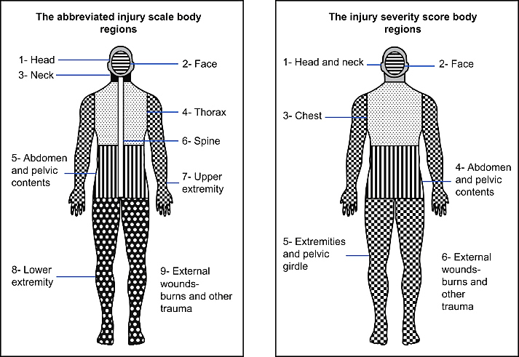

**Figure 1: The Abbreviated Injury Scale and Injury Severity Score Body Regions**





**Table 1: Summary of the Relevant Past Literature**

|  |  |  |
| --- | --- | --- |
| **Title** | **Reference** | **Key Findings** |
| Validating the Injury Severity Score (ISS) in Different Populations: ISS Predicts Mortality Better among Hispanics and Females | Bolorunduro, et al., 2011 | * The ISS is widely used as a measure of injury severity * It effectively predicts trauma mortality based on multiple data sets * The ISS demonstrates strong discriminative ability across all groups, based on race and gender |
| Towards Better Measurement of Traffic Injuries – Comparison of Anatomical Injury Measures in Predicting Clinical Outcomes in Motorcycle Crashes | Wali, et al., 2022 | * Despite its simplicity and clarity, the KABCO scale has significant limitations * The ISS is a more sophisticated scoring system than the KABCO scale, capable of accurately assessing overall injury severity and facilitating a more comprehensive evaluation |
| An Empirical Assessment of Factors Influencing Injury Severities of Motor Vehicle Crashes on National Highways of Pakistan | Hanif, et al., 2021 | * Factors such as overspeeding, driver fatigue, driver negligence, driver age, type of vehicle (truck, rickshaw, single vehicle), road conditions (horizontal curve, potholes, night driving without road lights), time/day/month of crash occurrence, weather conditions (e.g., cloudy, clear) contribute to the injury severity in a crash |
| Prehospital Care and 24-hour Crash Injury Mortality Among Road Traffic Crash Victims in Addis Ababa | Mengstu, et al, 2021 | * Without pre-hospital care, the chance of early death in RTCs is significantly higher * Key areas to focus on include reducing the time spent in the pre-hospital environment, using ambulance services, and increasing public awareness of pre-hospital care, particularly within the platinum 10-minute scene time and golden one-hour PHT |
| The Prehospital Time Impact on Traffic Injury from Hospital Fatality and Inpatient Recovery Perspectives | Sara et al, 2019 | * The impact of PHT differs among observations and is positively associated with duration of hospital stay and Healthcare costs * Factors such as age and gender of the victim, crash type, hospital, and injury severity (i.e., AIS) significantly influence both the likelihood of mortality and the recovery rate of crash victims |
| Emergency Medical Service Response Time for Road Traffic Accidents in the Kingdom of Saudi Arabia: Analysis of National Data (2016–2020) | Thamer, et al., 2023 | * Response time is significantly affected by various socio-demographic factors, such as geographical regions, causes of crash, age, gender, and nationality * Acquiring a thorough knowledge of these aspects is essential for optimizing efficiency during the PHT |
| Factors Affecting Prehospital Time Delay of the Injured Patients Arriving at the Emergency Department of Beni-Suef University Hospital in Egypt: A Cross-Sectional Study | Khalil, et al., 2021 | * The delay in receiving medical care before reaching the hospital is associated with old age, living in rural areas, and the level of consciousness of crash victims * Implementing health education programs aimed at educating elderly individuals and those living in rural areas about the importance of minimizing PHT is necessary |
| Time to Reach Healthcare Facility and Hospital Exit Outcome among Road Traffic Accident Victims Attending a Tertiary Care Hospital, Puducherry | Antony, et al., 2021 | * Various environmental and infrastructural factors, such as the day of the week, urban or rural location, specific crash details, and emergency response duration, significantly impact PHT |
| Factors Influencing Pre-Hospital Care Time Intervals in Iran: A Qualitative Study | Davoud, et al., 2018 | * The EMS play a crucial role in reducing the PHT * Challenges associated with prompt response include the collaboration of the public, the allocation of EMS facilities, the accessibility of ambulances, and the availability of personnel |
| Pre-Hospital Trauma Care in Road Traffic Accidents in Kashan, Iran | Paravar, et al., 2013 | * Trauma patients involved in RTCs on intercity roads have longer PHT and more serious injuries compared to those involved in RTCs on city streets * Consequently, this group requires more PHT-related measures |
| Influential Factors in Freeway Crash Response and Clearance Times by Emergency Management Services in Peak Periods | Lee et al, 2006 | * EMS response times are most significantly influenced by the severity of RTCs * RTCs resulting in injuries or fatalities have EMS response times up to 20% less than crashes exclusively involving property damage * Total PHT during peak periods is greatly influenced by the day of the week, urban or rural location, off or opposing-lane crash location, number of vehicles involved, heavy vehicle involvement, and reaction time |

**Figure 2: Conceptual Framework**

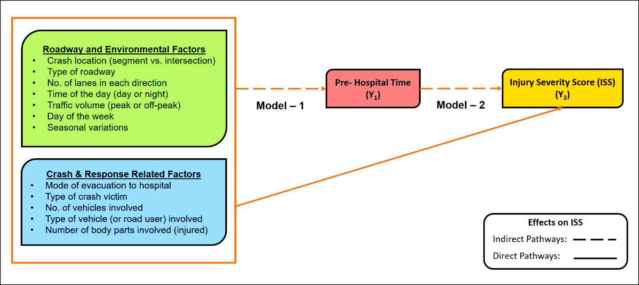

**Figure 3: Percentage-Wise Distribution of Variables - Observed (Actual) Versus Synthetic Data**

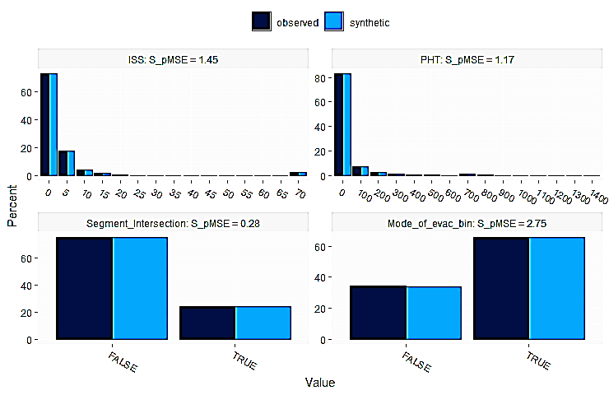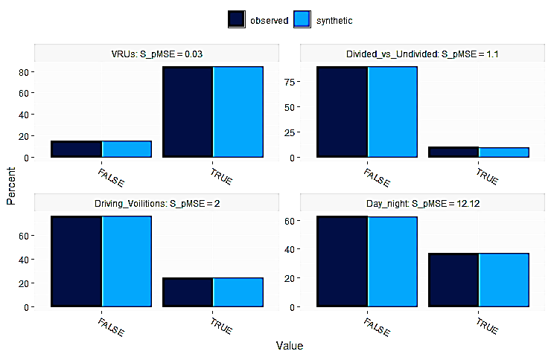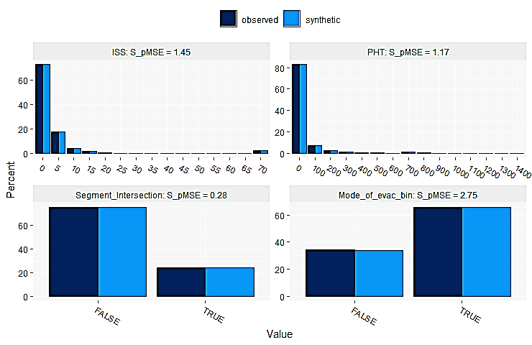

***Note:*** *False and true refer to 0 and 1 for the indicator variables respectively*

**Table 2: Descriptive Statistics - Actual Data versus Synthetic Data**

|  |  |  |  |  |  |
| --- | --- | --- | --- | --- | --- |
| **Observed Data** | | | | | |
| **Variable** | **Obs.** | **Mean** | **Std. Dev.** | **Min.** | **Max.** |
| ISS | 138,289 | 6.17 | 11.69 | 1 | 75 |
| PHT (in minutes) | 138,289 | 104.81 | 206.73 | 1 | 1439 |
| Crash Location (0 if segment, 1 if intersection) | 138,289 | 0.25 | 0.43 | 0 | 1 |
| Mode of Evacuation (1 if ambulance, 0 otherwise) | 138,289 | 0.66 | 0.47 | 0 | 1 |
| Type of Crash Victim (1 if VRU, 0 otherwise) | 138,289 | 0.86 | 0.34 | 0 | 1 |
| Type of Roadway (0 if divided, 1 otherwise) | 138,289 | 0.10 | 0.30 | 0 | 1 |
| **Synthetic Data** | | | | | |
| **Variable** | **Obs.** | **Mean** | **Std. Dev.** | **Min.** | **Max.** |
| ISS | 160,365 | 6.22 | 11.89 | 1 | 75 |
| PHT (in minutes) | 160,365 | 103.86 | 204.74 | 1 | 1439 |
| Crash Location (0 if segment, 1 if intersection) | 160,365 | 0.25 | 0.43 | 0 | 1 |
| Mode of Evacuation (1 if ambulance, 0 otherwise) | 160,365 | 0.66 | 0.47 | 0 | 1 |
| Type of Crash Victim (1 if VRU, 0 otherwise) | 160,365 | 0.87 | 0.33 | 0 | 1 |
| Type of Roadway (0 if divided, 1 otherwise) | 160,365 | 0.10 | 0.30 | 0 | 1 |

**Figure 4: Distribution of ISS and Pre-hospital Time**

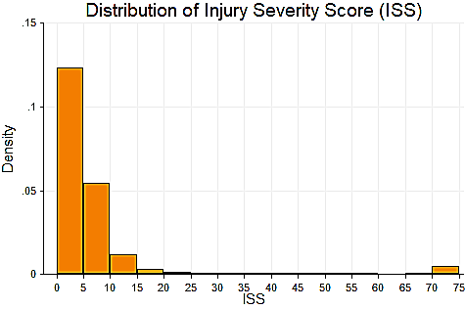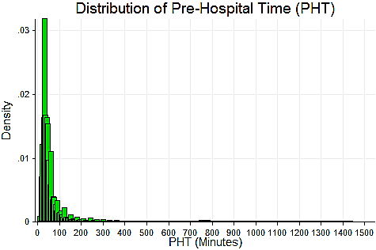

**Figure 5: Distribution of Type of Vehicles Involved, Type of Crash victims, and Mode of Evacuation**

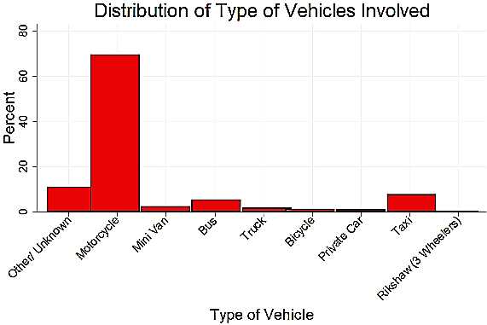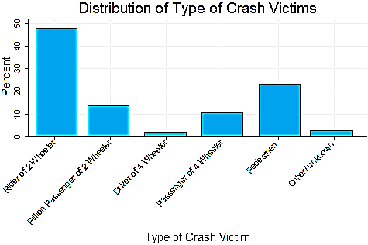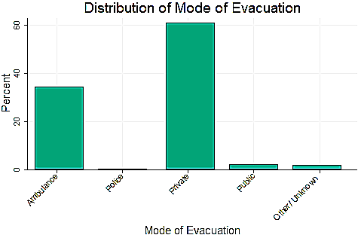

**Table 3: Descriptive Statistics of Key Variables**

|  |  |  |  |  |  |
| --- | --- | --- | --- | --- | --- |
| **Variable** | **Obs.** | **Mean** | **Std. Dev.** | **Min.** | **Max.** |
| **Dependent Variables** | | | | | |
| ISS | 298,654 | 6.20 | 11.80 | 1 | 75 |
| PHT (in minutes) | 298,654 | 104.30 | 205.66 | 1 | 1439 |
| **Independent Variables** | | | | | |
| **Roadway Environment and Traffic-Related Factors** | | | | | |
| Crash Location (0 if segment, 1 if intersection) | 298,654 | 0.25 | 0.43 | 0 | 1 |
| Type of Roadway (0 if divided, 1 otherwise) | 298,654 | 0.10 | 0.30 | 0 | 1 |
| Number of Lanes in Each Direction  (0 if 4 lanes, 1 if less than 4 lanes) | 298,654 | 0.35 | 0.48 | 0 | 1 |
| Time of the Day (0 if day, 1 otherwise) | 298,654 | 0.37 | 0.48 | 0 | 1 |
| Traffic Volume  (0 if morning peak, 1 otherwise) | 298,654 | 0.95 | 0.23 | 0 | 1 |
| Day of the Week (1 if Friday, 0 otherwise) | 298,654 | 0.13 | 0.34 | 0 | 1 |
| Seasonal Variations (0 if summer,1 otherwise) | 298,654 | 0.68 | 0.47 | 0 | 1 |
| **Crash and Response-Related Factors** | | | | | |
| Mode of Evacuation  (0 if ambulance, 1 otherwise) | 298,654 | 0.66 | 0.47 | 0 | 1 |
| Type of Crash Victim (1 if VRU, 0 otherwise) | 298,654 | 0.87 | 0.34 | 0 | 1 |
| Number of Vehicles Involved  (0 if single vehicle, 1 if multiple vehicles) | 298,654 | 0.35 | 0.48 | 0 | 1 |
| Heavy Vehicles vs Other  (1 if heavy vehicle i.e. truck or bus, 0 otherwise) | 298,654 | 0.08 | 0.27 | 0 | 1 |
| Number of Body Parts Injured | 298,654 | 1.90 | 0.91 | 1 | 8 |

**Table 4: Results of Model-1 (PHT Model)**

|  |  |  |  |  |  |  |
| --- | --- | --- | --- | --- | --- | --- |
| **PHT** | **Coef.** | **Std. Err.** | **t-stat** | **ME-1** | **ME-2** | **ME-3** |
| **Roadway Environment and Traffic-Related Factors** | | | | | | |
| Crash Location  (0 if segment, 1 if intersection) | -31.3014 | 0.8740 | -35.82 | -21.53 | -0.05 | -15.20 |
| Type of Roadway  (0 if divided, 1 otherwise) | 5.8517 | 1.4132 | 4.14 | 4.03 | 0.01 | 2.84 |
| Number of Lanes in Each Direction  (0 if 4 lanes, 1 if less than 4 lanes) | -14.8500 | 0.8847 | -16.79 | -10.21 | -0.03 | -7.21 |
| Time of the Day  (0 if day, 1 otherwise) | 23.5048 | 0.7820 | 30.06 | 16.17 | 0.04 | 11.41 |
| Seasonal Variations  (0 if summer,1 otherwise) | 2.4386 | 0.8067 | 3.02 | 1.68 | 0.00 | 1.18 |
| **Crash and Response-Related Factors** | | | | | | |
| Mode of Evacuation  (0 if ambulance, 1 otherwise) | -6.3341 | 0.8170 | -7.75 | -4.36 | -0.01 | -3.08 |
| Type of Crash Victim  (1 if VRUs, 0 otherwise) | -37.4407 | 1.2485 | -29.99 | -25.75 | -0.06 | -18.18 |
| Number of Vehicles Involved  (0 if single vehicle, 1 if multiple vehicles) | 3.9627 | 0.7991 | 4.96 | 2.73 | 0.01 | 1.92 |
| Heavy Vehicles vs Other  (1 if heavy vehicle, 0 otherwise) | 30.8792 | 1.5850 | 19.48 | 21.24 | 0.05 | 14.99 |
| Number of Body Parts Injured | 9.7848 | 0.4170 | 23.46 | 6.73 | 0.02 | 4.75 |
| Constant | 119.0316 | 1.7351 | 68.60 | - | - | - |
| Sigma | 205.4065 | 0.2678 | - | - | - | - |
| **Model Summary** | | | | | | |
| Log Likelihood | -1992007 | | | | | |
| AIC | 3984038 | | | | | |
| BIC | 3984165 | | | | | |

***Note:*** *The Variance Inflation Factors (VIF) were calculated to assess multicollinearity among variables, and the values for all the key regressors were less than 1.27 (well below the threshold of 10), indicating the absence of problematic collinearity.*

**Table 5: Results of Model-2 (ISS Model)**

|  |  |  |  |  |  |  |
| --- | --- | --- | --- | --- | --- | --- |
| **ISS** | **Coef.** | **Std. Err.** | **t-stat** | **ME-1** | **ME-2** | **ME-3** |
| PHT | 0.0111 | 0.0004 | 27.32 | 0.01 | 0.0003 | 0.004 |
| c.PHT#c.PHT | -0.00001 | 0.0000004 | -23.25 |  |  |  |
| **Roadway Environment and Traffic-Related Factors** | | | | | | |
| Crash Location  (0 if segment, 1 if intersection) | -0.6464 | 0.0612 | -10.56 | -0.36 | -0.02 | -0.27 |
| Type of Roadway  (0 if divided, 1 otherwise) | 0.6556 | 0.0990 | 6.62 | 0.37 | 0.02 | 0.27 |
| Number of Lanes in Each Direction  (0 if 4 lanes, 1 if less than 4 lanes) | -0.4880 | 0.0620 | -7.87 | -0.28 | -0.01 | -0.20 |
| Time of the Day  (0 if day, 1 otherwise) | 0.5749 | 0.0555 | 10.36 | 0.32 | 0.02 | 0.24 |
| Traffic Volume  (0 if morning peak, 1 otherwise) | -1.4299 | 0.1159 | -12.34 | -0.81 | -0.04 | -0.59 |
| Day of the Week  (1 if Friday, 0 otherwise) | 0.2037 | 0.0778 | 2.62 | 0.11 | 0.01 | 0.08 |
| Seasonal Variations  (0 if summer,1 otherwise) | -0.1559 | 0.0562 | -2.77 | -0.09 | -0.01 | -0.06 |
| **Crash and Response-Related Factors** | | | | | | |
| Mode of Evacuation  (0 if ambulance, 1 otherwise) | -6.9258 | 0.0560 | -123.58 | -3.91 | -0.19 | -2.85 |
| Type of Crash Victim  (1 if VRUs, 0 otherwise) | 0.7227 | 0.0865 | 8.35 | 0.41 | 0.02 | 0.30 |
| Number of Vehicles Involved (0 if single vehicle, 1 if multiple vehicles) | 1.0494 | 0.0556 | 18.87 | 0.59 | 0.03 | 0.43 |
| Heavy Vehicles vs Other  (1 if heavy vehicle, 0 otherwise) | 2.2932 | 0.1087 | 21.09 | 1.29 | 0.06 | 0.94 |
| Number of Body Parts Injured | 3.6425 | 0.0295 | 123.28 | 2.05 | 0.10 | 1.50 |
| Constant | 0.6223 | 0.1647 | 3.78 | - | - | - |
| Sigma | 13.5519 | 0.0206 | - | - | - | - |
| **Model Summary** | | | | | | |
| Log Likelihood | -947745 | | | | | |
| AIC | 1895522 | | | | | |
| BIC | 1895691 | | | | | |

***Note:*** *While values for the t-stat and MEs are reported up to two decimal places, values for the coefficients and standard error are reported up to four. However, to account for the first non-zero value after the decimal points, there are minor differences in how PHT and its squared term are reported. Moreover, the VIF values for all the key regressors are also less than 1.27 (well below the threshold of 10), indicating the absence of problematic collinearity.*

**Table 6: Path Analysis Results: Direct, Indirect, and Total Effects of Key Variables**

|  |  |  |  |
| --- | --- | --- | --- |
| **Independent Variables** | **Direct Effects** | **Indirect Effects** | **Total Effects** |
| PHT | 0.01 | - | 0.01 |
| **Roadway Environment and Traffic-Related Factors** | | | |
| Crash Location  (0 if segment, 1 if intersection) | -0.36 | -0.22 | -0.58 |
| Type of Roadway  (0 if divided, 1 otherwise) | 0.37 | 0.04 | 0.41 |
| Number of Lanes in Each Direction  (0 if 4 lanes, 1 if less than 4 lanes) | -0.28 | -0.10 | -0.38 |
| Time of the Day  (0 if day, 1 otherwise) | 0.32 | 0.16 | 0.48 |
| Traffic Volume  (0 if morning peak, 1 otherwise) | -0.81 | - | -0.81 |
| Day of the Week  (1 if Friday, 0 otherwise) | 0.11 | - | 0.11 |
| Seasonal Variations  (0 if summer,1 otherwise) | -0.09 | 0.02 | -0.07 |
| **Crash and Response-Related Factors** | | | |
| Mode of Evacuation  (0 if ambulance, 1 otherwise) | -3.91 | -0.04 | -3.95 |
| Type of Crash Victim  (1 if VRUs, 0 otherwise) | 0.41 | -0.26 | 0.15 |
| Number of Vehicles Involved  (0 if single vehicle, 1 if multiple vehicles) | 0.59 | 0.03 | 0.62 |
| Heavy Vehicles vs Other  (1 if heavy vehicle, 0 otherwise) | 1.29 | 0.21 | 1.50 |
| Number of Body Parts Injured | 2.05 | 0.07 | 2.12 |

**Figure 6: Path Analysis: Direct and Indirect Effects of Key Variables on Injury Severity Score**

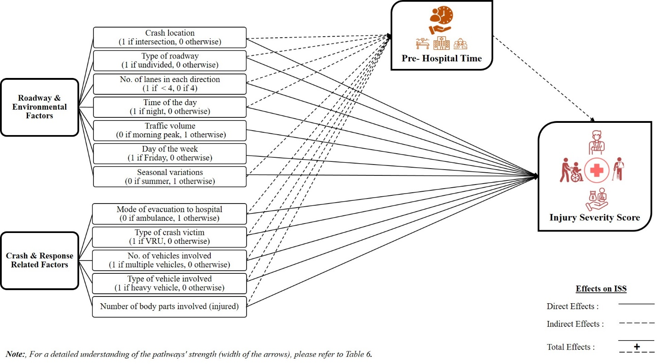

***Note:*** *For a detailed understanding of the pathways' strength (width of the arrows), please refer to Table 6.*

**Ethics statement**

This study analyzes the RTCs data acquired from the Road Traffic Injuries Research and Prevention Center (RTIRPC) focused on Karachi, Pakistan. The data used for analysis do not include sensitive information. The authors declare no conflicts of interest.

**Conflict of Interest**

The authors declare that there is no conflict of interest.